LightSoft’s Northbound Interface
to IDF OSS
based on LightSoft’s Northbound Interface rev 1.7
April 14, 2005

This document contains proprietary information of ECI Telecom and of the TeleManagement Forum, and is not to be used for any other purpose than planning the LightSoft-OSS interface, and is not to be given to anyone who does not need it for the purpose of this interface or to be used for any other purpose.

1 Introduction 2
1.1 Scope 2
1.2 Abbreviations 2
1.3 Overview 3
2 LightSoft Multilayer Subnetwork (MLSN) 4
3 SNC/Trail Rates 4
4 Topology Links 4
5 UMEs 5
5.1 Uploading UMEs 5
5.2 LS trails on UMEs 5
5.3 UME object association and naming 5
6 Trails and SNCs 6
6.1 EMS SNCs (cross-connects) 6
6.2 SNC Types 6
6.3 SNC States 7
6.4 Server Trails 7
6.5 SNC parameters and attributes 7
6.6 Editing and Reconnecting SNCs 8
6.7 SNCs on UMEs 9
6.8 Unique IDs for uploaded SNCs 9
7 No EMS visibility 9
8 Edge PTPs 9
9 Inconsistency 10
10 Naming and General Object Mapping Rules 10
11 Supported Notifications 11
11.1 Lifecycle Notifications & LightSoft-OSS Synchronization 11
11.2 Alarms, TCAs, and other Events 11
11.3 Notification Configurations 14
12 Supported Operations 15

Introduction

Scope
This document explains the usage of MTMN as the Northbound Interface from ECI’s LightSoft NMS to the IDF OSS. It includes some ECI proprietary extensions to MTMN. Features currently planned for LightSoft 2.5 are presented. Some features which may be supported in the future are also presented.
This document refers to attributes, attribute values, and parameters defined in eNI documentation. The latest version documentation of eNI 2.0B should be consulted.

Abbreviations
AID object type for objects not modeled in MTNM
AVC Attribute Value Change (type of notification)
CORBA software system used for communicating between parts of a distributed system
CTP Connection Termination Point
DN Distinguished Name
EML Element Management Level
EMS Element Management System
EoS Ethernet over SDH/SONET (type of client trail)
eNI ECI Northbound Interface
IDF OSS OSS used in the IDF to manage its telecom transport network
LS LightSoft, the name of ECI’s network management system
LSN LightScape Networks, former name of the ECI Optical Networks Division
ME Managed Element
MLSN Multilayer Subnetwork
MTNM Multi-Technology Network Model (interface defined by TeleManagement Forum)
NMS Network Management System
OC Object Creation notification
OD Object Deletion notification
OSS Operations Support System
OTN Optical Transport Network
PGP Protection Group
PM Performance Monitoring
PTP Physical Termination Point (usually same as Port)
RDN Relative Distinguished Name
SDH Synchronous Digital Hierarchy (telecom transport protocol)
SNMS SubNetwork Management System (same as NMS, for part of a network)
SNC SubNetwork Connection
SONET telecom transport protocol, similar to SDH, used in North America
STM Synchronous Transport Module (top of the SDH hierarchy)
Syncom older family of telecom multiplexers developed and sold by ECI
TBD to be decided
TCA Threshold Crossing Alert (when a PM counter crosses a configured threshold)
TMF TeleManagement Forum (www.tmforum.org)
TP Termination Point
TSI Time Slot Interchange (when a path doesn’t use the same TU for its entire length)
ULMS Upper Level Management System (i.e., any “north” end of the interface)
UME Unmanaged Element
VCn A layer rate in the SDH hierarchy
XDM family of telecom multiplexers developed and sold by ECI

Overview
LightSoft supports a northbound interface based on definitions from TMF814 v2.1. The interface provides support for provisioning, fault management, basic maintenance, and PM operations, for all managed EMSs, including EMS-XDM, EMS-Syncom, and others (including some EMSs which manage non-ECI equipment).
Provisioning is supported by LightSoft in the Subnetwork view, where the entire NMS topology is represented as a single Subnetwork. LightSoft provides the ability to provision connections between edge ports of the Subnetwork. For High Order / server connections, LightSoft may allow provisioning also between ports that are not on the edge of the Subnetwork.

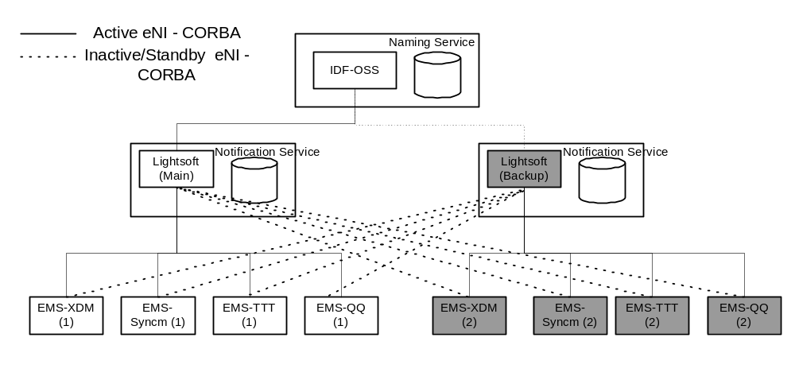

LightSoft Multilayer Subnetwork (MLSN)

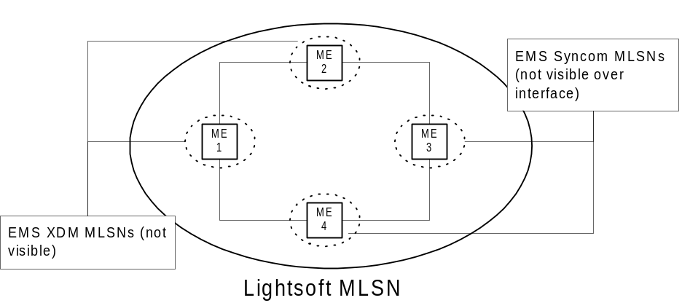

The entire LightSoft topology, including all technology layers, is reported in a single Multilayered Subnetwork (MLSN). Subnetwork Connections (SNCs) are created through the MLSN object. SNCs correspond to either end-to-end trails or to the part of the trail that is managed and known within the LightSoft Subnetwork. The Subnetwork therefore spans all MEs. MEs that are provided over the interface correspond to the LightSoft MEs at the “physical technology layer”. It includes also unmanaged MEs (UMEs).
The Subnetwork Type, of the subnetwork presented to the IDF OSS (which is the entire LightSoft network), is always TOPO_MESH.

SNC/Trail Rates
All layer rates which are handled by LightSoft are supported by the northbound interface.

Topology Links
- Topological links are discovered but not created over the interface.
- All links are provided as internal links of the LS Subnetwork.
- Virtual links created in a client technology layer in LightSoft (e.g. SDH is a client of OTN) shall be reported to the IDF-OSS as links on the same PTP. They are also reported as trails in the server layer. AdditionalInfo in the TopologyLink object is supported to indicate the underlying trail of a virtual link.

AdditionalInfoAttribute name | Values | AVC | Comment
LSNExt_UnderlyingTrail | String – RDN of the underlying trail; points to lightpath or EoS trail | Yes | Only appears for virtual links.  (e.g. RDN is the last part of the LP-STM DN)

- Topology links connecting UMEs are provided over the interface, for UMEs which are uploaded to the IDF-OSS. See chapter 5.

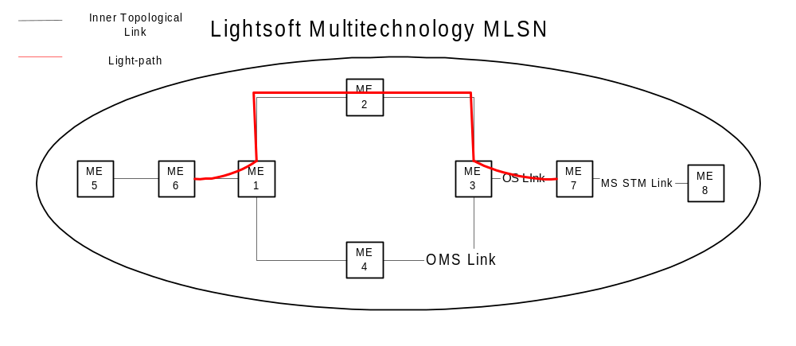

UMEs

Uploading UMEs
There are situations where not uploading UMEs would give a distorted view of the network, e.g., LS trails going through UMEs (i.e., connected to LS MEs on either side of the UME). Also, a UME may represent customer equipment which the IDF-OSS might not have another way of knowing. It’s not always possible to “ignore” a UME, e.g., to connect directly the XDMs on either side of a non-terminal UME, because the links may be of different STM levels and trails may have TSIs, so the UME needs to be uploaded.
All UMEs will be uploaded to the IDF-OSS.
In future versions of Lightsoft, UMEs will have an attribute that indicates if a UME should be uploaded to the IDF-OSS or not. A UME shall be uploaded, or not, according to the value of that new attribute, without regard to there being a through trail or not. The default value shall be “do not upload”. A change to the value of the “upload this UME” attribute will result in all the necessary notifications to the IDF-OSS, involving the UME, its links, and its trails.

LS trails on UMEs
Trail endpoints on UMEs are discussed in chapter 6.
In the future, when not all UMEs are uploaded, a LS trail which goes through a UME, which has not been uploaded to the IDF-OSS, will be uploaded to the IDF-OSS with a gap in its route.

UME object association and naming
UMEs shall be uploaded as Managed Elements, and shall be included in all requests of the “getManagedElements” type. The “productName” attribute shall be set to “UME-xxx”, where “xxx” is the type of UME. When the type cannot be supplied, the attribute shall be simply “UME”.
The name of a UME is the same as the name in the LS database. Regarding the possible loss of a UME identification due to loss of the LS database, it is the network administration’s responsibility to keep adequate backups of the LS database information, so that the information regarding UMEs (as well as lots of other important information) is not lost.

Trails and SNCs

EMS SNCs (cross-connects)
EMS SNCs are provided as crossconnect data structures. For example, in the SNC operation getRoute(), returns the list of cross-connects. However, cross-connects are not MTNM objects over this interface.

SNC Types
The possible SNC types are explained below. The ST_EXPLICIT shall be supported. Other types may be supported in the future.
    - ST_EXPLICIT
ST_EXPLICIT is used in MTNM to model types of connectivity which are not covered by the other, implicit SNC types. Examples are 1) “Different TUs” in inverse directions of a trail, and 2) Flex Trails. However, it can be used for the implicit SNC types as well.
    - ST_SIMPLE
LightSoft point-to-point unprotected and protected trails ending at a single TP at each end can be presented as ST_SIMPLE.
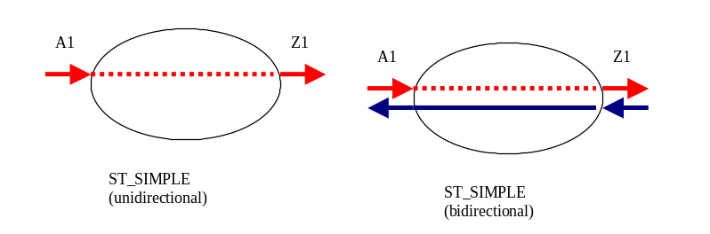
    - ST_ADD_DROP_A and ST_ADD_DROP_Z
LightSoft Y-trails could be presented as ST_ADD_DROP.
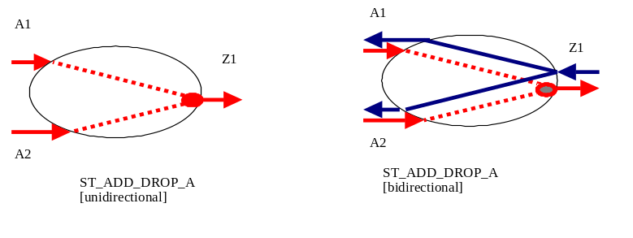
    - ST_DOUBLE_ADD_DROP
LightSoft X-trails that have switch points can be presented as ST_ADD_DROP.
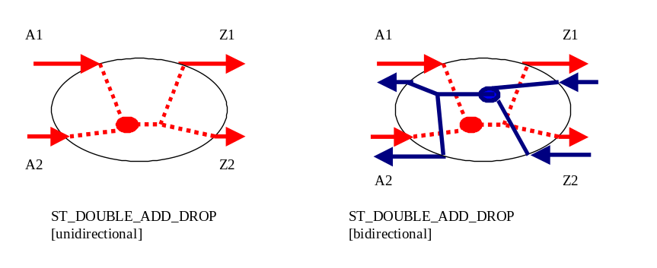

SNC States
- SNCS_ACTIVE when all cross-connects have been successfully created and activated in the NEs.
- SNCS_PARTIAL when one or more cross-connects has not been successfully created and activated.
LightSoft does not allow a trail to be defined without creating it in the network. In other words, LightSoft does not support the “Pending” state of trails.

Server Trails
LightSoft supports the explicit creation and presentation of server trails via the Northbound Interface.
LightSoft’s handling of server trails is semi-automatic. When an SDH link is established between XDMs, the server trails are created automatically and are available to carry low-order trails. However, when non-server high-order trails are needed, or server trails which traverse XDMs (i.e., not just linking two adjacent XDMs), the existing server trails must be manually deleted and the new high-order trails created. When the high-order are no longer needed, and are deleted, they are not automatically replaced by regular server trails. The regular server trails should either be manually recreated immediately, or manually created as needed for low-order traffic.

SNC parameters and attributes
EMS Freedom Level – Since explicit provisioning of high order server trails must be done in order to createAndActivate an SNC requested at the client layer, only EMSFL_CC_AT_SNC_LAYER is supported. Other values may be supported in the future.
Static Protection Level – there is a difference between the MTNM definitions of the values of this parameter and the ECI definitions. LightSoft shall support the MTNM definitions in the northbound interface.
The StaticProtectionLevel will take one of the following values: {PREEMPTIBLE, UNPROTECTED, PARTIALLY_PROTECTED, FULLY_PROTECTED, HIGHLY_PROTECTED}.
The StaticProtectionLevel values are defined as follows:
PREEMPTIBLE: Has resources that can be taken to recover another SNC, which will result in this SNC not functioning. This is not relevant to IDF OSS.
UNPROTECTED: An SNC that will fail if any resource in its route fails.
PARTIALLY_PROTECTED: Protection exists but has at least one shared node, shared fiber (includes shared link or shared optical section), or shared SRLG name.
FULLY_PROTECTED: An SNC that will not fail if any single managed resource along its route fails (excluding the originating and terminating nodes for the SNC); for example, an SNC that is diversely routed at any layer.
HIGHLY_PROTECTED: A higher level of protection than is possible by simple diverse path routing. Typically this is achieved in a SONET/SDH environment using dual ring interworking, where the proper use of links enhances survivability over that offered by simple diverse path routing. Highly Protected is used when the IDF-OSS wishes to request the highest available protection level from LS. A SNC or trail which qualifies as Fully Protected, and also has a DRI part, is considered Highly Protected. (Note that DRI does not include DNI for this purpose.)
Protection Effort - EFFORT_WHATEVER and EFFORT_SAME shall be supported. Other values may be supported in the future.
Routing Constraints - Only constraints supported for LightSoft operators need be supported over the northbound interface. For example, routing constraints for “inclusion” must be of the trail layer or its direct server layer (e.g., for a VC12 trail, a VC4 server trail may be selected as a constraint, but not a topology link). Other routing constraints may be supported in the future.
Routing optimization criteria, as specified in eNI specifications, including “LSN” extensions, shall be supported.

Editing and Reconnecting SNCs
SNCs can be edited by using the “LSNExt_EditSNCName” additionalInfo parameter, whose value is the name of the SNC to be edited. Changes in the SNCCreateData will be made to the named SNC.
An SNC, which has SNCState = Partial, can be reconnected (i.e., attempt to connect all of the cross-connections which have failed to be made thusfar) by “editing” the SNC with all of the SNCCreateData being identical to the attributes of the SNC.

SNCs on UMEs
Trails which end on a UME, or on two UMEs, will be uploaded with the endpoint(s) on the UME. The IDF-OSS can create trails with endpoints on UMEs.
In future LightSoft versions, when not all UMEs are uploaded:
When a LS trail has an endpoint on a UME, and the UME is not uploaded to the IDF-OSS, the endpoint of the SNC presented to the IDF-OSS shall be the LS-managed CTP which is closest to the UME.
Trails with endpoints on a UME, which is uploaded to the IDF-OSS, can be uploaded either with the UME endpoint(s) or with the CTP endpoint(s), as described above.
The IDF-OSS can create a trail with endpoints on CTPs. When LS creates the trail, it will find the right UME port to use as an endpoint within LS. If there is no such UME, an appropriate UME will be created.

Unique IDs for uploaded SNCs
Uploaded SNCs will be uniquely identified by the Trail ID maintained in LightSoft. This ID will be part of the SNC’s DN when uploaded.
Regarding the possible loss of a SNC ID due to loss of the LS database, it is the network administration’s responsibility to keep adequate backups of the LS database information, so that the information regarding SNCs (as well as lots of other important information) is not lost.

No EMS visibility
The IDF-OSS will not have visibility into information about the EMSs which are managed by LS, when LS is being managed by the IDF-OSS. The only information is the name of EMSs which appear as prefixes to the names of their MEs.

Edge PTPs
Since the IDF-OSS can connect to any available port (as far as LS is concerned), and it can get the full list via getALLPtps, the interface gives “edge PTP” the meaning that it can be an endpoint to a LightSoft trail.
A PTP shall be considered an edge PTP, in the following cases:
  - Any non-UME PTP which does not have an internal link connected to it is considered to be an edge PTP.
  - Any non-UME PTP which does have an internal link connected to it, and the link is to another non-UME PTP, is not considered to be an edge PTP.
  - Any non-UME PTP which has a link connected to it, and the link is to a UME (whether or not the UME is to be uploaded to the IDF-OSS), is considered to be an edge PTP. (This is because the IDF-OSS can define a trail with an endpoint on a CTP of this PTP.)
  - A UME PTP, of a UME which is uploaded to the IDF-OSS, is an edge PTP if it has a link connected to it, and is not an edge PTP if it does not have a link connected to it.
The addition or removal of a link, which affects the “edge-ness” of a PTP, causes an AVC to the IDF-OSS, indicating the change in the “edge” status of the PTP.

Inconsistency
- Two additionalInfo parameters will be added to the Managed Element, Termination Point, and Topology Link objects, to indicate an inconsistent state.
  - LSNExt_Inconsistent, with values {True, False}. True means Inconsistent. When the parameter is not included, it is the same as False.
  - LSNExt_InconsistencyReason, with values (where relevant): Object deleted, Conflict, Invalid object, Manual Out of Service
- An additionalInfo parameter will be added to the MultiLayer Subnetwork object, to indicate the “red flag” or “yellow flag” condition. This parameter is LSNExt_TrafficConsistency, with values {TC_CONSISTENT, TC_INCONSISTENT, TC_INCONSISTENT_IN_layer}. There is no indication whether the condition is “red” or “yellow”. When the parameter is not included, it is the same as TC_CONSISTENT. If the inconsistency is only in one layer, the TC_INCONSISTENT_IN_layer form will be used. Otherwise, if in multiple layers or the layer is not known, TC_INCONSISTENT is used. The “layer” part of TC_INCONSISTENT_IN_layer shall be one of the following: EMS, OCH, OMS, LP, HO, LO.
- The IDF OSS should have some strategy for dealing with inconsistencies.

Naming and General Object Mapping Rules
- Naming of MEs and Network Element Layer (NEL) resources: these include all objects contained in MEs, such as TPs, ProtectionGroup, EquipmentHolder, Equipment. Such objects shall be identified over the interface according to the following rules.

Name | Value | Comment
EMS | ECI/LIGHTSOFT_n | n is SNMS Id {1,..,n}
ManagedElement | EMSname/MEname | EMSname is the name of the EMS as provided by EMS;  MEname is the original ME identifier as provided by EMS  note: UMEs are presented as Managed Elements; the name is the name known in LS; there is no EMSname
PTP, CTP, PGP, Equipment or EquipmentHolder. | Same as from the EMS | Same as from the EMS
Example of a CTP name:
{(EMS, "ECI/LIGHTSOFT_1"), (ManagedElement, "LSN/EMS_XDM_1/87"), (PTP, "27:5"), (CTP, "/sts3c_au4=2")}
- Some objects shall only be mapped from the objects as they exist in LightSoft. An example is the Subnetwork and topological links. EMS subnetworks shall not be provided. Topological links shall be provided only for links that are recognized in LightSoft.
Name | Value | Comment
EMS | ECI/LIGHTSOFT_n | n is SNMS Id {1,..,n}
MultiLayerSubnetwork | 1 | A single subnetwork is provided, which combines the LightSoft technology layers.

Name | Value | Comment
EMS | ECI/LIGHTSOFT_n | n is SNMS Id {1,..,n}
TopologicalLink | endPtp1/endPtp2/direction/rate | For bidirectional links, endPtps appear in alphabetical order. For unidirectional links, the source PTP precedes the sink PTP. Direction and Rate are code numbers.  This form is used to guarantee uniqueness, to avoid errors due to multiple links appearing by mistake in the LS db.

Supported Notifications

Lifecycle Notifications & LightSoft-OSS Synchronization
LightSoft shall provide the IDF-OSS all of the object lifecycle notifications that are necessary for the IDF-OSS to maintain synchronization with LightSoft.
The following lifecycle notifications should be provided for all of the objects in the above and their applicable attributes:
Object Creation - Managed Element, SNC, PTP, PGP, TopologyLink, AID
Object Deletion - Managed Element, SNC, PTP, PGP, TopologyLink, AID
AVC - All objects
State Change - All applicable objects
Route Change Notification - SNCs
SNCs are LightSoft trails, and not EMS cross-connects, as explained in chapter 2.
ManagedElement should be created in the unsynchronized state. A state change should be provided as soon as LightSoft allows the IDF-OSS to query the ManagedElement for all of the contained PTPs (i.e. as soon as the NE is "recognized"). Alternatively LightSoft may provide Object Creation on all of the ME’s PTPs once the ME is created.
The IDF OSS should not upload from MEs which are in the unsynchronized state.

Alarms, TCAs, and other Events
For the purpose of fault management, all alarms and TCAs are forwarded to the IDF-OSS. Quality of Service or PM alarms reported by NEs (when applicable) are mapped to TCAs over the LightSoft - IDF-OSS interface.
No designated notification is defined for Equipment protection switch or Timing Reference switch. This issue is resolved within eNI by issuing a non-clearable alarm containing the following information:
probableCause: UNIDENTIFIED
nativeProbableCause: IOP Switch | Timing Switch
additionalText: From: <Timing Reference Name | Equipment Name> To: <Timing Reference Name | Equipment Name> Reason: <reason of the switch e.g. maintenance>
Service Alarms of XDM NEs are reported by the EMS-XDM as an alarm on the cross-connect. LightSoft will map this alarm into the interface to correlate the alarm to its SNC. The objectName will refer to the LightSoft trail, and the nativeEMSName will refer to the EMS SNC (i.e., the crossconnect).
LightSoft shall generate internal alarms for the same reasons that EMS-XDM produces them, where relevant. These alarms, and any other internal LightSoft alarms, shall be sent to the IDF-OSS. The alarmed object is EMS (meaning LightSoft). An alarm received by LightSoft, from a managed EMS, shall be sent to the IDF-OSS. The alarmed object will be a Managed Element, whose name is the name of the EMS (i.e., EMSname without /MEname).
The following table shows the fields of alarm and TCA notifications:

Name | Type | Description
"notificationId" | string | Alarm Id known to the LightSoft database.
"objectName" | globaldefs::NamingAttributes_T | Identifies the LightSoft object reporting the alarm. AID type objects must be uniquely identified.
"nativeEMSName" | string | Identifies the object as portrayed on the LightSoft user interface. If objectType is AID, use the native EMSName sent by the EMS.
"nativeProbableCause" | string | Identifies the probableCause as portrayed on the EMS user interface.
"objectType" | notifications::ObjectType_T | Identifies the type of object reporting an alarm.
"emsTime" | globaldefs::Time_T | The time at which the event was reported by the LightSoft system.
"neTime" | globaldefs::Time_T | The time provided by the NE related to the alarm. In a case where the NE does not report time, empty string shall be reported.
"isClearable" | boolean | Indicates if the event is clearable (or is itself a clear).
"layerRate" | transmissionParameters::LayerRate_T | The layer which this alarm is relevant to.
"probableCause" | string | No other string than the ones defined below should be used for this field.
"probableCauseQualifier" | string | Used with objectName, layerRate, and probableCause to uniquely identify an alarm.  eNI format is defined as "<A>@@<B>@@<C>" where:  <A> = unsigned integer ( <= 11 bits )  <B> = unsigned integer ( <= 3 bits )  <C> = unsigned integer ( <= 16 bits)
"perceivedSeverity" | notifications::PerceivedSeverity_T | Indicates the severity of the alarm. Perceived severity should be set to PS_INDETERMINATE for AT_TRANSIENT_EVENT conditions
"serviceAffecting" | notifications::ServiceAffecting_T | Indicates whether the alarm has affected some service. When LightSoft has an algorithm by which it computes this value, the computed value will be used. Otherwise, the value sent by the EMS will be used.
"affectedTPList" | globaldefs::NamingAttributesList_T | A list of affected TPs. Contained CTPs are not listed. This field is optional (indicated by an empty string) for all alarms except for alarms on equipment. This is used to indicate a list of TPs affected by an equipment failure for example. If the alarm is an alarm on an equipment that supports PTPs, then the ports (PTPs) supported by this equipment will be listed in this field (irrespective of whether the alarm is Service Affecting or not). The list should be ordered by PTP names (ASCII order).  If the EMS sends a list of affected TPs also for non-equipment alarms, this list should be sent also to the IDF-OSS.
"additionalText" | string | More information about the alarm, such as, "Unit is mismounted".
"granularity" | Granularity_T | Carries the details of the threshold that has been crossed, in a TCA
"pmParameterName" | PMParameterName_T | Carries the details of the threshold that has been crossed, in a TCA
"pmLocation" | PMLocation_T | Carries the details of the threshold that has been crossed, in a TCA
"thresholdType" | PMThresholdType_T | Carries the details of the threshold that has been crossed, in a TCA
"value" | float | Carries the details of the threshold that has been crossed, in a TCA. This parameter is sent to the IDF-OSS only if it was received from the EMS.
"unit" | string | Carries the details of the threshold that has been crossed, in a TCA. This parameter is sent to the IDF-OSS only if it was received from the EMS.
additionalInfo – “LSNExt_AckStatus” | Possible values:  {"ALM_ACKNOWLEDGED", "ALM_UNACKNOWLEDGED", "ALM_NA"} | Indicates that the alarm has been acknowledged by a user.
additionalInfo -  "LSNExt_AckUser" | free format string | Indicates the user name of the user that has acknowledged the alarm.

Notification Configurations
There are three possible notification service configurations. The actual configuration used in a specific installation will be determined through agreement between ECI and the IDF-OSS implementer.
The notification service configuration that the IDF-OSS is using is indicated by a prefix on the “user” parameter sent in the getEMSSession function.
The possible configurations are:
1. LightSoft Northbound Notification Service (described below)
No prefix on “user” parameter.
ECI strongly recommends that IDF OSS use this service.
2. Standard MTNM Notification Service (defined by TMF)
“MTNM” prefix on “user” parameter.
3. LSN Internal Notification Service (not described in this document)
“LSN” prefix on “user” parameter.
LightSoft Northbound Notification Service
TCAs are reported with Object Type “TCA”, and not as alarmed events
A single channel is used for all types of notifications.
A loss of an event, reported to the IDF-OSS, can happen. (For example, due to overflow of the Notification Service buffer or due to loss internal to LightSoft). A loss of an event can be sensed, using the following mechanism:
An event will be marked with a unique and consecutive number. Each notification type has its own count, as follows:
- Alarms and TCAs - single NotificationId counter shall be used (even though they are two distinct MTNM notification types)
- OC
- OD
- AVC
- State Change
- Route Change
- Protection Switch
- File Transfer Status
Note that the first event (of a certain type) received by the IDF-OSS may not necessarily be numbered “1”. But every event after the first will be numbered consecutively, starting with the number of the first one received. The event following the event with the maximum number will be numbered “1”. The maximum number will be agreed for integration.
The IDF-OSS detects a loss of notifications when two consecutive events do not have consecutive numbers.

Supported Operations
This chapter presents a table of operations which are defined in the MTNM v2.1 standard of the TeleManagement Forum. It explains which operations will be supported in the NorthBound interface between LightSoft and the IDF OSS, in which LightSoft version they will be supported, which operations are not relevant to the IDF OSS, and why other operations in the list are not expected to be supported.
The columns marked v2, v2.5, and v3, indicate that an operation will be supported in LightSoft version 2, 2.5, or 3, respectively, when a  appears in the operation’s row in the version’s column. Operations which are not planned for support in one of these versions have an explanatory note, which is indicated in the “see note” column. The notes appear after the table. The “in SOW” column indicates which operations appear in the SOW.

 | MTNM 2.1 Server Side Functions | v2 | v2.5 | v3 | see note | in SOW?
 | EMSMgr
 | getAllEMSAndMEActiveAlarms |  |  |  |  | 
 | getAllEMSSystemActiveAlarms |  |  |  | 6) | 
 | getAllTopLevelSubnetworkNames |  |  |  | 1) | 
 | getAllTopLevelSubnetworks |  |  |  |  | 
 | getAllTopLevelTopologicalLinkNames |  |  |  | 9)
 | getAllTopLevelTopologicalLinks |  |  |  | 9)
 | getTopLevelTopologicalLink |  |  |  | 9)
 | getCapabilities |  |  |  |  | 
 | getEMS |  |  |  |  | 
 | setNativeEMSName |  | 
 | setOwner |  | 
 | setUserLabel |  | 
 | EmsSession
 | associatedSession |  |  |  |  | 
 | endSession |  |  |  |  | 
 | getEventChannel |  |  |  |  | 
 | getManager |  |  |  |  | 
 | getSupportedManagers |  |  |  |  | 
 | ping |  |  |  |  | 
 | EmsSessionFactory
 | getEmsSession |  |  |  |  | 
 | EquipmentInventoryMgr
 | getAllEquipment |  |  |  | 3) | 
 | getAllEquipmentNames |  |  |  | 4), 5)
 | getAllSupportingEquipment |  |  |  | 3) | 
 | getAllSupportedPTPs |  |  |  | 3) | 
 | getAllSupportedPTPNames |  |  |  | 4) , 5)
 | getAllSupportingEquipmentNames |  |  |  | 4) , 5)
 | getContainedEquipment |  |  |  | 4) , 5)
 | getEquipment |  |  |  | 4) , 5)
 | provisionEquipment |  |  |  | 11)
 | setAlarmReportingOff |  |  |  | 11)
 | setAlarmReportingOn |  |  |  | 11)
 | unprovisionEquipment |  |  |  | 11)
 | EquipmentOrHolderIterator
 | destroy |  |  |  | 4)
 | getLength |  |  |  | 4)
 | next_n |  |  |  | 4)
 | NamingAttributesIterator
 | destroy |  |  |  |  | 
 | getLength |  |  |  |  | 
 | next_n |  |  |  |  | 
 | GuiCutThroughMgr
 | destroyGCT |  |  |  |  | 
 | getCapabilities |  |  |  |  | 
 | getGCTProfileInfo |  |  |  |  | 
 | launchGCT |  |  |  |  | 
 | CurrentMaintenanceOperationIterator
 | destroy |  |  |  |  | 
 | getLength |  |  |  |  | 
 | next_n |  |  |  |  | 
 | MaintenanceMgr
 | getActiveMaintenanceOperations |  |  |  |  | 
 | getCapabilities |  |  |  |  | 
 | performMaintenanceOperation |  | 12) |  |  | 
 | ManagedElementIterator
 | destroy |  |  |  |  | 
 | getLength |  |  |  |  | 
 | next_n |  |  |  |  | 
 | ManagedElementMgr
 | getAllActiveAlarms |  |  |  |  | 
 | getAllCrossConnections |  |  |  | 9)
 | getAllManagedElementNames |  |  |  | 1) | 
 | getAllManagedElements |  |  |  |  | 
 | getAllPTPNames |  |  |  | 1) | 
 | getAllPTPs |  |  |  |  | 
 | getCapabilities |  |  |  |  | 
 | getContainedCurrentTPNames |  |  |  | 1)
 | getContainedCurrrentTPs |  |  |  | 1)
 | getContainedInUseTPNames |  |  |  | 1)
 | getContainedInUseTPs |  |  |  | 1)
 | getContainedPotentialTPNames |  |  |  | 1)
 | getContainedPotentialTPs |  |  |  |  | 
 | getContainingSubnetworkNames |  |  |  |  | 
 | getContainingTPNames |  |  |  | 1)
 | getContainingTPs |  |  |  | 1)
 | getManagedElement |  |  |  | 1) | 
 | getTP |  |  |  | 1) | 
 | setNativeEMSName |  |  |  |  |  7)
 | setOwner |  | 
 | setTPData |  |  |  |  | 
 | setUserLabel |  | 
 | Version
 | mtnmVersion::getVersion |  |  |  |  | 
 | MultiLayerSubnetworkMgr
 | activateSNC |  |  |  | 9)
 | checkValidSNC |  |  |  |  | 
 | createAndActivateSNC |  |  |  |  | 
 | createSNC |  |  |  | 9)
 | deactivateAndDeleteSNC |  |  |  |  | 
 | deactivateSNC |  |  |  | 9)
 | deleteSNC |  |  |  | 9)
 | getAllEdgePointNames |  |  |  | 1) | 
 | getAllEdgePoints |  |  |  |  | 
 | getAllManagedElementNames |  |  |  | 1) | 
 | getAllManagedElements |  |  |  |  | 
 | getAllSubnetworkConnectionNames |  |  |  | 1) | 
 | getAllSubnetworkConnectionNamesWithTP |  |  |  | 1)
 | getAllSubnetworkConnections |  |  |  |  | 
 | getAllSubnetworkConnectionsWithTP |  |  |  | 1) | 
 | getAllTopologicalLinkNames |  |  |  | 1)
 | getAllTopologicalLinks |  |  |  |  | 
 | getAllTPPoolNames |  |  |  | 9)
 | getAllTPPools |  |  |  | 9)
 | getAssociatedTP |  |  |  | 2) | 
 | getCapabilities |  |  |  |  | 
 | getMultiLayerSubnetwork |  |  |  | 1) | 
 | getRoute |  |  |  |  | 
 | getSNC |  |  |  | 1) | 
 | getSNCsByUserLabel |  |  |  | 1) | 
 | getTopologicalLink |  |  |  | 1)
 | getTPGroupingRelationships |  |  |  | 9)
 | setNativeEMSName |  | 
 | setOwner |  | 
 | setUserLabel |  | 
 | SubnetworkIterator
 | destroy |  | 
 | getLength |  | 
 | next_n |  | 
 | NmsSession
 | associatedSession |  |  |  | 10)
 | endSession |  |  |  | 10)
 | eventLossOccured |  |  |  | 8)
 | eventLossCleared |  |  |  | 8)
 | ping |  |  |  | 10)
 | EventIterator (notifications)
 | destroy |  |  |  |  | 
 | getLength |  |  |  |  | 
 | next_n |  |  |  |  | 
 | PerformanceManagementMgr
 | clearPMData |  | 
 | disablePMData |  | 
 | disableTCA |  |  |  | 9)
 | enablePMData |  | 
 | enableTCA |  |  |  | 9)
 | getAllCurrentPMData |  |  |  |  | 
 | getCapabilities |  | 
 | getHistoryPMData |  |  | 
 | getHoldingTime |  |  |  | 6)
 | getMEPMCapabilities |  |  |  | 9)
 | getTCATPParameter |  |  |  |  | 
 | setTCATPParameter |  |  |  | 9)
 | PMDataIterator
 | destroy |  | 
 | getLength |  | 
 | next_n |  | 
 | ProtectionGroupIterator
 | destroy |  | 
 | getLength |  | 
 | next_n |  | 
 | ProtectionMgr
 | getAllNUTTPNames |  |  |  | 2)
 | getAllPreemptibleTPNames |  |  |  | 2)
 | getAllProtectedTPNames |  |  |  | 1)
 | getAllProtectionGroups |  |  |  |  | 
 | getCapabilities |  | 
 | getProtectionGroup |  |  |  | 1) | 
 | performProtectionCommand |  |  |  |  | 
 | retrieveSwitchData |  |  |  |  | 
 | setNativeEMSName |  | 
 | setOwner |  | 
 | setUserLabel |  | 
 | Session – see EmsSession and NmsSession
 | CCIterator
 | destroy |  |  |  | 9)
 | getLength |  |  |  | 9)
 | next_n |  |  |  | 9)
 | SNCIterator
 | destroy |  |  |  |  | 
 | getLength |  |  |  |  | 
 | next_n |  |  |  |  | 
 | TerminationPointIterator
 | destroy |  |  |  |  | 
 | getLength |  |  |  |  | 
 | next_n |  |  |  |  | 
 | TopologicalLinkIterator
 | destroy | 
 | getLength | 
 | next_n | 
 | totals: | 30 | 56 | 2 | 67 | 77

Notes
- We recommend that the IDF OSS work the same way as LightSoft, maintaining a local copy of the information which is uploaded, using the “getAllxxx” operators. The function in this row is then unnecessary, making the interface simpler and integration easier. The information provided by this function is already in the OSS local copy.
- This function is not relevant in the IDF network.
- Although at the time the SOW was written we intended to support this function, we have since concluded that it is not really needed, and recommend that they be left out of the interface. This will make integration easier and we believe the loss in functionality is minimal.
- Not relevant without other operations of this module.
- Even if other operations of this module would be supported, we would not consider this operation needed.
- The information supplied by this function is easily obtained by some other supported function.
- This appears in the SOW as getNativeEMSName, by mistake.
- We recommend that the IDF OSS use the event numbering scheme, making this function unnecessary.
- MTNM operation which is either not relevant in LightSoft or not relevant in the LS Northbound interface.
- This operation is only for LightSoft use. IDF OSS uses the EmsSession operations.
- LightSoft doesn’t use this operation, so there is no reason for the IDF OSS to ask LightSoft to do it.
- Only “Acknowledge Alarm” will be supported in v2. The other maintenance operations (whatever maintenance operations are supported in LightSoft) will be provided in v2.5.

